**NAME: PRIYA LAKHOTIYA**

**ER. NO.: 180089**

**END TERM PRACTICAL EVALUATION**

**OBJECTIVE:** Write a program for implementing the Linear Search.

1. Using Array

**CODE:**

#include<stdio.h>

#include<conio.h>

void main(){

clrscr();

int a[25],n,i,key,c=0;

printf("Enter the size of array fron 1 to 25: ");

scanf("%d",&n);

printf("Enter the elements of the array:\n");

for(i=0;i<n;i++){

scanf("%d",&a[i]);

}

printf("Enter the value to be searched: ");

scanf("%d",&key);

for(i=0;i<n;i++){

if(a[i]==key){

c=1;

break;

}

}

if(c==1){

printf("The value %d is found at position: %d",key,i+1);

}

if(c==0){

printf("Value not found");

}

getch();

}

**Output:**

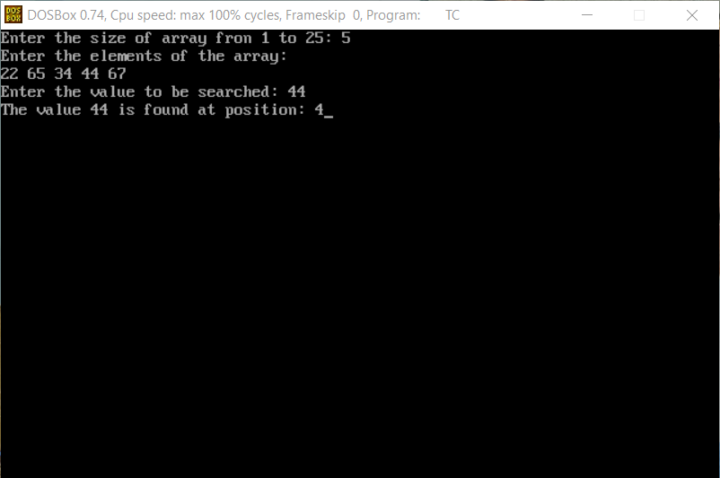

1. Using Linked List

**CODE:**

#include<stdio.h>

#include<stdlib.h>

#include<conio.h>

struct node{

int data;

struct node *link;

};

struct node *head,*n;

void insert(){

int x;

struct node *ptr;

ptr=head;

printf("Enter the value of new node: ");

scanf("%d",&x);

n=(struct node *)malloc(sizeof(struct node));

n->data=x;

if(head==NULL){

n->link=NULL;

head=n;

}else{

while(ptr->link!=NULL){

ptr=ptr->link;

}

n->link=NULL;

ptr->link=n;

}

}

void traversal(){

struct node *ptr;

ptr=head;

if(head==NULL){

printf("List is empty");

getch();

}

else{

while(ptr!=NULL){

printf("%d-> ",ptr->data);

ptr=ptr->link;

}

getch();

}

}

void srch(){

struct node *ptr;

ptr=head;

int c=0,key,i=0;

if(head==NULL){

printf("List is empty");

getch();

}

else{

printf("Enter the value to search: ");

scanf("%d",&key);

while(ptr!=NULL||c==1){

if(ptr->data==key){

c=1;

break;

}

else{

ptr=ptr->link;

i=i+1;

}

}

if(c==1){

printf("The value %d is found at position: %d",key,i+1);

getch();

}

if(c==0){

printf("Value not found");

getch();

}

}

}

void main(){ clrscr();

int c;

L:system("cls");

printf("1. Insertion\n");

printf("2. Traversal\n");

printf("3. Search\n");

printf("4.Exit\n");

printf("Enter your choice: ");

scanf("%d",&c);

switch(c){

case 1:

insert();

goto L;

case 2:

traversal();

goto L;

case 3:

srch();

goto L;

case 4:

exit(0);

default:

printf("Invalid choice...Enter your choice again");

getch();

goto L;

}

getch();

}

**Output:**

